**Web designing assignment**

**Term-2**

**Module (CSS and CSS 3) -2**

**1)What are the benefits of using CSS?**

**Ans)**CSS stands for cascading style sheets. In short, CSS is a design language that makes a website look more appealing than just plain or uninspiring pieces of text.

**1) Faster Page Speed**

More code means slower page speed. And CSS enables you to use less code. CSS allows you to use one CSS rule and apply it to all occurrences of a certain tag within an HTML document.

**2) Better User Experience**

CSS not only makes web pages easy on the eye, it also allows for user-friendly formatting. When buttons and text are in logical places and well organized, user experience improves.

**3) Quicker Development Time**

With CSS, you can apply specific formatting rules and styles to multiple pages with one string of code. One cascading style sheet can be replicated across several website pages. If, for instance, you have product pages that should all have the same formatting, look, and feel, writing CSS rules for one page will suffice for all pages of that same type.

**4) Easy Formatting Changes**

If you need to change the format of a specific set of pages, it’s easy to do so with CSS. There’s no need to fix every individual page. Just edit the corresponding CSS stylesheet and you’ll see changes applied to all the pages that are using that style sheet.

**5) Compatibility Across Devices**

Responsive web design matters. In today’s day and age, web pages must be fully visible and easily navigable on all devices. Whether mobile or tablet, desktop, or even smart TV, CSS combines with HTML to make responsive design possible.

**2)What are the disadvantages of CSS?**

### Ans) These all are disadvantages of css

### ****\*** Confusion due to many CSS levels**

Beginners are more vulnerable to this issue. They might get confused while opting to learn CSS as there are many levels of CSS such as CSS2, CSS3, etc.

### ****\*** Cross-Browser Issues**

Different browsers work differently. So, you have to check that changes implemented in the website via CSS codes are reflected properly among all browsers.

### ****\*** Security Issues**

Security is important in today’s world driven by technology and data. One of the major disadvantages of CSS is that it has limited security.

### ****\*** Extra Work for Developers**

Design services are required to consider and test all CSS codes across different browsers for compatibility. Due to developers testing compatibility for different browsers, their workload increases.

**3)What is the difference between CSS2 and CSS3?**

**Ans)**Here are some of the key differences between CSS2 and CSS3:

* **Flexbox:** Flexbox is a layout module that makes it easier to create responsive layouts.
* **Grid:**Grid is a layout module that provides more control over the layout of elements on a web page.
* **Animations:** CSS3 adds support for animations, which can be used to create more dynamic web pages.
* **Transitions:** CSS3 adds support for transitions, which can be used to create smooth transitions between states of an element.
* **Custom properties:** CSS3 adds support for custom properties, which can be used to create reusable styles.
* **Improved support for media queries:** CSS3 improves the support for media queries, which can be used to adjust the layout of a web page for different screen sizes.
* **Better performance:** CSS3 code is typically more efficient than CSS2 code, which can lead to faster page load times. Overall, CSS3 is a more powerful and versatile stylesheet language than CSS2. It offers a number of new features that make it easier to create responsive, dynamic, and visually appealing web pages.

**4) Name a few CSS style components :**

Ans)

*Inline *Selector *Value of property *Attribute

Doctype html *External CSS *Internal CSS *External

**1) COLOUR AND BACKGROUND**

**Colour:-** sets the text colour.

**Background:-** Sets the background colour.

**2)** **MARGIN AND PADDING**

**MARGIN:** Define the space outside an element

**PADDING:** Sets the space inside an element

**3) BOX MODEL:-**

**WIDTH:-** Sets the width an element.

**HEIGHT:-** Sets the height of an element.

**BOX SIZING:**- Controls how the element`s width and height are calculated.

**4)** **LAYOUT:-**

**DISPLAY:** Specifies how an element is positioned within its container

**FLOAT:** Allows elements to float to the left or right within their containers.

**5) What do you understand by CSS opacity?**

Ans)

To set the opacity of a background, image, text, or other element, you can use the CSS opacity property. Values for this property range from 0 to 1. If you set the property to 0, the styled element will be completely transparent.

*The opacity property takes values from 0.0 to 1.0 , with 1 being the default value for all elements

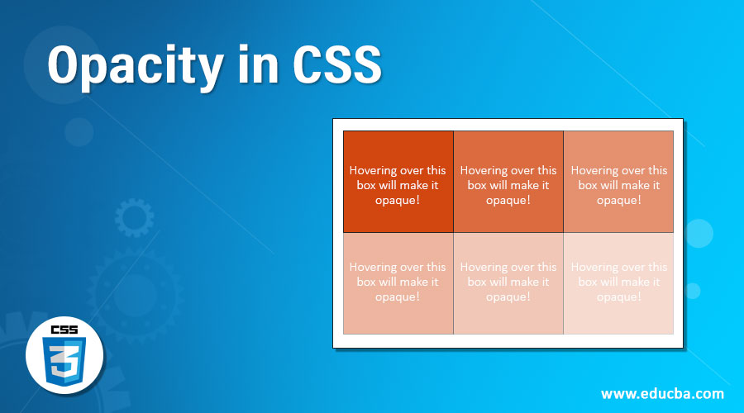

**6) How can the background color of an element be changed?**

**Ans)** To add background color in HTML, use the CSS background-color property. Set it to the color name or code you want and place it inside a style attribute.

  <H1 style="background-color: yellow;">BACKGROUND</H1>



**7)How can image repetition of the backup be controlled?**

**Ans)** This task can be achieved by using the background-repeat property that will help us to control the repetition of the image.

<style>

  .image{

    background-image: url(Foreground\ \(1\).png);

    background-repeat: no-repeat;

  }

</style>

**8)**

This property allows you to specify whether and how a background image should be repeated in both the horizontal and vertical directions.